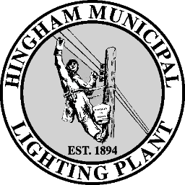

HINGHAM MUNICIPAL LIGHTING PLANT
31 Bare Cove Park Drive

Hingham, MA 02043
(781) 749-0134 FAX (781) 749-1396
www.hmlp.com

General Manager Board Members
Thomas Morahan Laura Burns, Chair
tmorahan@hmlp.com Michael Reive, Vice-Chair
Joseph Fisher, Secretary

MUNICIPAL LIGHT BOARD

August 25, 2026

4:00 PM
This meeting is being held remotely as an alternate means of public access pursuant to Chapter 2 of the Acts of 2025 and all other applicable laws temporarily amending certain provisions of the Open Meeting Law. You are hereby advised that this meeting and all communications during this meeting may be recorded by the Town of Hingham in accordance with the Open Meeting Law. If any participant wishes to record this meeting, please notify the chair at the start of the meeting in accordance with M.G.L. c. 30A, § 20(f) so that the chair may inform all other participants of said recording.

Zoom Meeting
https://us02web.zoom.us/j/82296001923
Meeting ID: 822 9600 1923
Passcode: 677295
One tap mobile
+16465588656,,82296001923#,,,,*677295# US (New York)

Agenda

- Call meeting to order

- Rate Study – Utility Financial Solutions (UFS)

- Warrant Article on Borrowing Authorization Vote

- Warrant Article to Extend the Borrowing from 20 to 30 Years Vote

- Other New Unforeseen Business
- Motion to Adjourn

